SACCO CREDIT RISK LOGISTIC REGRESSION MODEL RESULTS

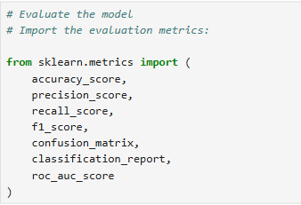
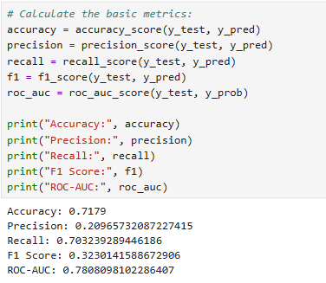
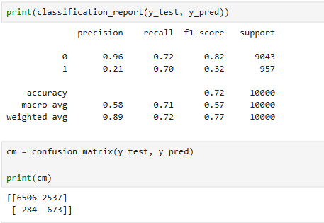

-- A confusion matrix is a simple table that shows how well a classification model’s predictions match the actual results.

Predicted 0 Predicted 1
Actual 0 6506 2537
Actual 1 284 673

-- The total number of borrowers from the confusion matrix table above are 96790+3210) = 10,000 instead of the 50,000 borrowers in the dataset.
-- This is because when splitting the model features, 20% of the 50000 borrowers were assigned for TESTING, which is 10,000 borrowers.
-- Also, when creating the logistic regression model,we assigned it class_weight = ‘balanced’ as shown below.
-- This means the model gave more importance to the minority class when learning, which in this case is the default class 1. The dataset had 9.6% = 10% (when rounded off) defaulters compared to the majority 90.4% non-defaulters.
-- Without balancing, the model could focus heavily on the majority class because there are so many examples and we want the model to specifically learn to predict defaulters.
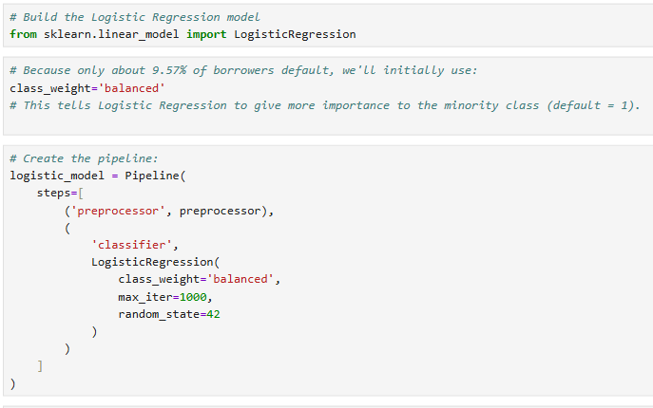
ACCURACY.
-- Accuracy answers the question: Of all the total predictions the model made(both default and non-default), how many of the predictions were correct.
-- The model made a total of ( 6506+284) = 6790 non-default predictions and a total of (2537+673) = 3210 default predictions. These 10000 predictions. Out of these, 6506 and 673 were correct = 7179 correct predictions.
-- The accuracy will become 7179/10000 = 0.7179 = 71.79%.
PRECISION.
-- From the table above, the logistic regression model predicted 3210 (2537+673) defaulters and 6790(6506+284) non-defaulters. These two columns add up to 10000 borrowers which verifies the 20% data test size.
-- Precision answers the questions: Of all the defaulters the model predicted, how many were actually true/positive?’ and ‘Of all the non-defaulters the model predicted, how many were actually true/positive?’.
-- Of all the defaulters the model predicted(3210), 673 were actually true/positive. This gives us the class 1 precision as 673/3210 = 0.2097 = 0.21 (when rounded off)
-- Of all the non-defaulters the model predicted(6790), 6506 were actually true/postie. This gives us the class 0 precision as 6506/6790 = 0.9581 = 0.96(when rounded off)
-- The above two precision are backed up in the classification report.
RECALL
-- From the confusion matrix table, there were 9043 (6506+2537) actual non-defaulters and 957 (284+673) actual defaulters. These two rows add up to 10000 borrowers which verifies the 20% data test size.
-- Recall answers the questions: ‘Of all the actual defaulters, how many did the model correctly identify?’ and ‘Of all the actual non-defaulters, how many did the model correctly identify?’
-- Of all the actual defaulters(957), the model correctly identified 673 defaulters. This gives the class 1 recall as 673/957 = 0.7032 = 0.70 (when rounded off)
-- Of all the actual non-defaulters, the model correctly identified 6506 non-defaulters. This gives the class 0 recall as 6506/9043 = 0.7195 = 0.72 (when rounded off).
-- The above two precision are backed up in the classification report.

PRIORITY
-- Our priority are the defaults.
-- Precision = 0.2097: This is the biggest weakness. Because out of all the defaulters the model predicted, 21% were true and 79% were wrong.
-- We want the model to correctly predict as many defaulters as possible.
-- So the model is currently flagging/predicting many borrowers as potential defaulters who ultimately did not default. For a SACCO, this could mean unnecessarily sending many potentially good applications for additional review or declining/limiting credit if the prediction were used directly for decisions.
-- If the model is used in this state, many actual non-defaulters will be denied loans because the model falsely identifies them as potential defaulters

-- Recall = 0.7032: This means the model identified about 70% of the actual defaulters in the test set.That's important for a lender because the model is catching a substantial portion of borrowers who actually defaulted. But it also means approximately 30% of actual defaulters were missed. That, is 284 actual defaulters were missed.
ROC-AUC

-- ROC-AUC essentially asks:“How good is my model at ranking actual defaulters above non-defaulters across different thresholds?”
-- This is probably the most encouraging result from this first model.
ROC-AUC = 0.7808. A ROC-AUC of 0.781 means your model has a fairly good ability to distinguish between defaulters and non-defaulters.
-- If you randomly choose one defaulter and one non-defaulter, your model will rank the defaulter as having a higher default risk about 78.1% of the time.
-- Think of it like a ranking test. Suppose:
Borrower A actually defaulted → model gives 80% default probability
Borrower B did not default → model gives 30% default probability
-- The model correctly ranks A above B. An AUC of 0.781 means it makes this kind of correct ranking fairly often across many pairs.
THRESHOLDS.
-- Currently, Logistic Regression uses approximately
Probability >= 0.50 → default
Probability < 0.50 → non-default
-- But there's no rule saying a SACCO has to use 0.50.we could investigate: 0.20, 0.30, 0.40, 0.50, 0.60, 0.70
-- At each threshold, precision and recall will change.
-- conceptually:
Lower threshold
↓
More borrowers classified as risky
↓
Higher recall
↓
Potentially lower precision
Whereas:
Higher threshold
↓
Fewer borrowers classified as risky
↓
Potentially higher precision
↓
Potentially lower recall

-- And there's another important portfolio point: we shouldn't expect Logistic Regression to necessarily be the strongest model. That's why your project includes Gradient Boosting.So your current result is a baseline, not the final model.
-- The key business interpretation is: The baseline Logistic Regression model can identify a substantial share of actual defaults, but at the current classification threshold it generates many false positive risk flags(out of all the defaulters the model predicted, 21% were true and 79% were wrong). Its ROC-AUC of 0.781 suggests useful discriminatory ability, so the next step is to examine probability thresholds and compare it with a tree-based model.

Logistic Regression
↓
Current baseline
↓
Evaluate threshold behavior
↓
Tune/compare model
↓
Gradient Boosting
↓
Compare models
↓
Final evaluation on test set
↓
Credit-risk probability
↓
Risk categories

TEST SEVERAL THRESHOLDS
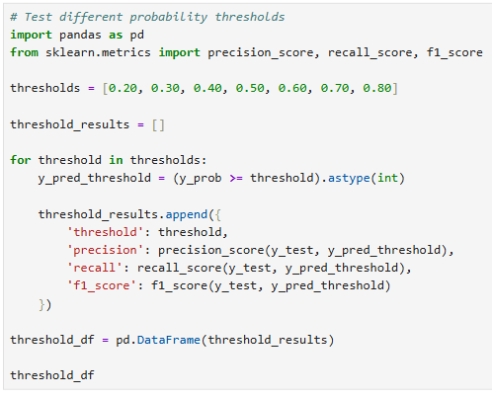
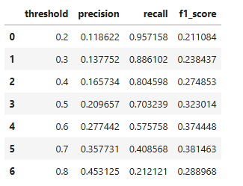
LOWER THRESHOLD
-- As the threshold decreases, the precision also decreases(that is, of all the default predictions the model made, very few were true and most of the other predictions were false(more false positives). On the hand, recall increases(of all the actual defaulters, the model identified more of them). That is more borrowers are flagged as defaulters.
More borrowers flagged as default
↓
Recall tends to increase
↓
More false positives

HIGHER THRESHOLD
-- As the threshold increases, the precision also increases and the recall decreases.

Fewer borrowers flagged as default
↓
Precision tends to increase
↓
Some actual defaults are missed

FIND THE THRESHOLD WITH THE HIGHEST F1
-- We can identify the threshold that gives the highest F1 score
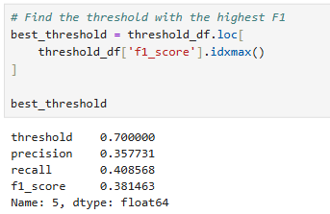

-- This doesn't mean we've found the "best" threshold for a real SACCO. The appropriate threshold depends on the lender's objectives and the costs of false positives versus missed defaults.
-- For our portfolio project, though, it gives us a transparent baseline threshold-selection exercise.
VISUALIZE THE TRADE-OFF
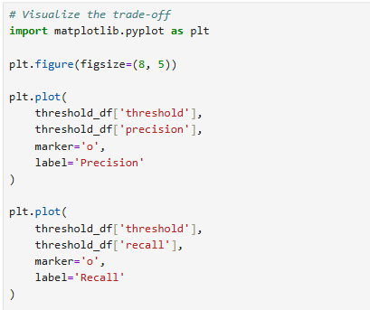
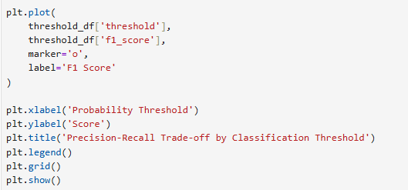
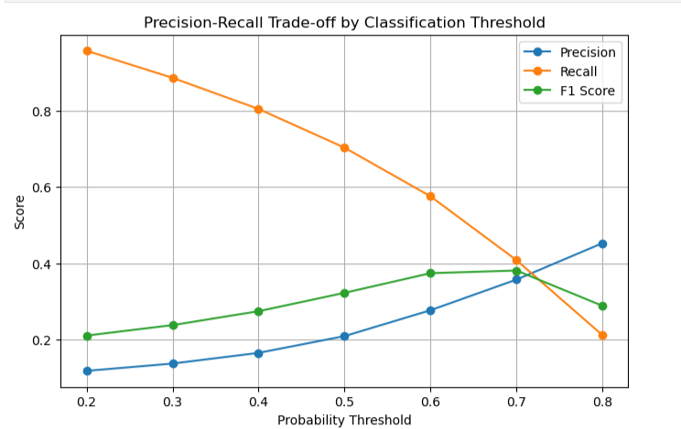

WHY THIS MATTERS FOR YOUR PORTFOLIO
-- This demonstrates that you understand something beyond I trained a Logistic Regression model and got 78% ROC-AUC.
-- You're showing that you understand how a credit-risk model would actually be used
-- For example, a lender might care more about:
- catching as many risky applications as possible(increase recall) or
- reducing the number of good borrowers incorrectly flagged as risky(increase precision).

-- Those are different operating objectives, so the threshold should be chosen based on the business context.

CONCLUSION.
-- ROC-AUC = 0.7808. A ROC-AUC of 0.781 means your model has a fairly good ability to distinguish between defaulters and non-defaulters.
-- If you randomly choose one defaulter and one non-defaulter, your model will rank the defaulter as having a higher default risk about 78.1% of the time.

-- Best Threshold
-- 0.70 produced the highest F1 among the tested thresholds.
-- So raising the threshold from 0.50 to 0.70:
- increased precision from 20.97% → 35.77%
- reduced recall from 70.32% → 40.86%
- increased F1 from 32.30% → 38.15%
-- More importantly, F1 isn't automatically the correct business objective. A SACCO might care more about minimizing missed defaults (recall) or minimizing good borrowers incorrectly flagged (precision).

-- Our Logistic Regression model has:
- ROC-AUC = 0.781 → useful ability to distinguish the two classes.
- At 0.50, it catches many defaults but generates many false positives.
- At 0.70, it becomes more selective, improving precision and F1 but missing more actual defaults.

